Kinsella, Charles V
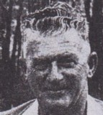
One of the first students of the Ludlow Apprentice Training School. Apprenticed 1917. Worked for Forests Department in 1920s-1950s. District Forester and OIC at Gleneagle in 1949. Appointed Senior Forester. Died 26.3.1965.

